**Unit V Work sheet**

1. Two friends Ramu and Somu playing head or tail game. The game has four rounds. While playing each round before flipping the coin, they are asked to take a number plate from the bowl which contains number plates of 1, 2 and 3. If they got number 1 only one chance is given the flip the coin. If they got number 2, two chances are given to flip the coin. If they got number 3, three chances are given to flip the coin. Following are the observations of each round.

***Round 1***

Ramu – Number Plate1: Tail

Somu – Number Plate2: Tail Head

***Round 2***

Ramu – Number Plate1: Head

Somu – Number Plate2: Tail Head

***Round 3***

Ramu – Number Plate3: Head Tail Head

Somu – Number Plate2: Head Tail

***Round 4***

Ramu – Number Plate2: Tail Tail

Somu – Number Plate1: Tail

Create two list from the observations named R for Ramu’s outcome and S for Somu’s outcome. Check whether the PCP has a solution?

**Solution:**

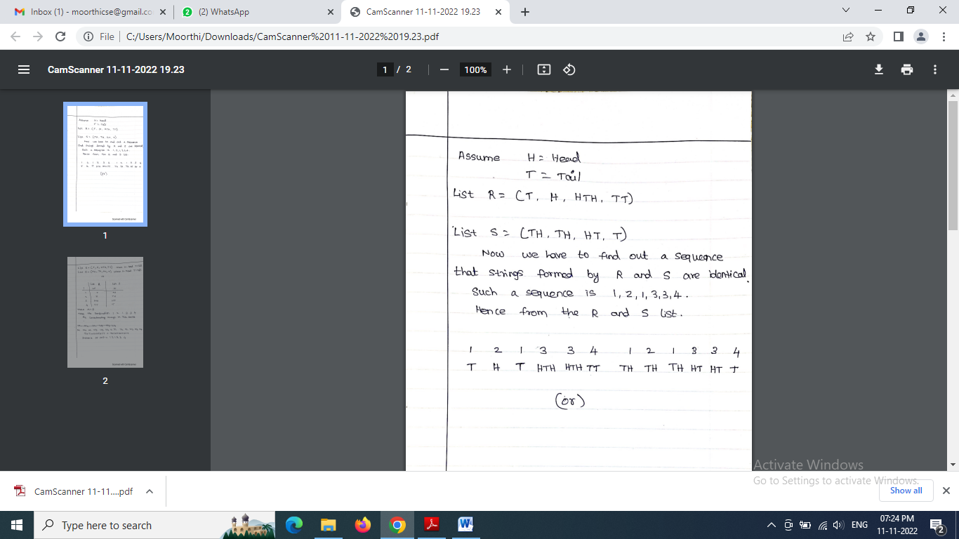

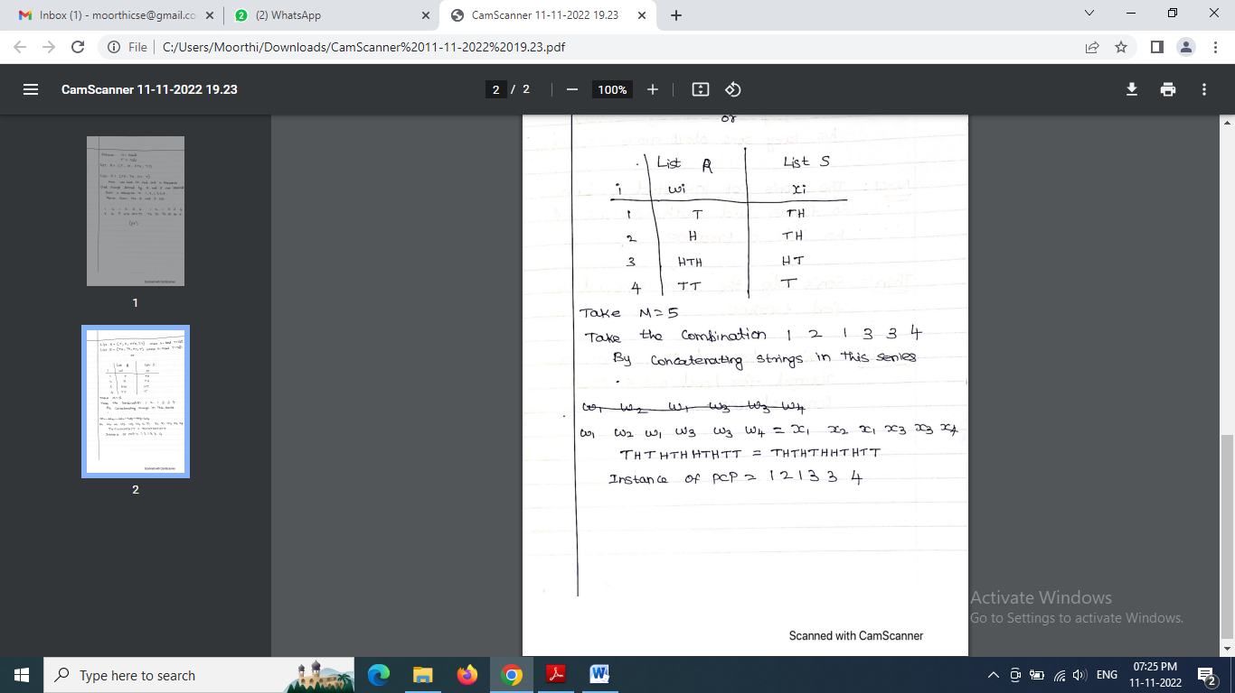

1. Consider the following solitaire game. You are given an m × m board where each one of the m2 positions may be empty or occupied by either a red stone or a blue stone. Initially, some configuration of stones is placed on the board. Then, for each column you must remove either all of the red stones in that column or all of the blue stones in that column. (If a column already has only red stones or only blue stones in it then you do not have to remove any further stones from that column.) The objective is to leave at least one stone in each row. Finding a solution that achieves this objective may or may not be possible depending upon the initial configuration. Let SOLITAIRE = {⊆G∈| G is a game configuration with a solution}.

i. Prove that SOLITAIRE is in NP (8 Marks)

ii. Show that 3SAT is reducible to SOLITAIRE (10 marks)

iii. A problem which is both _______ and _________ is said to be NP complete. (1

mark)

a) P and NP

b) NP and NP hard

c) P and NP hard

d) P and P hard

iv. Consider three decision problem A, B, C. A is decidable and B is not. Which of the following

is a correct option?

a) C is undecidable if C is reducible to B

b) C is undecidable if B is reducible to C

c) C is decidable if A is reducible to C

d) C is decidable if C is reducible to B’s complement.

1. To organize graduation day ceremony in the University, volunteers are invited from student’s community. Equal number of boys and girls are selected to organize the event.
2. Construct Turing machine with transition table or transition function that accepts only if the number of boys and girls in the organizing team is equal. (5 Marks)
3. Write the codes for the above Turing machine by encoding all the transition functions. (5 Marks)
4. Construct the Modified PCP (MPCP) instance for the above Turing machine. (8 Marks)
5. Check whether the string 01 has solution or accepted using MPCP instance.

(5 Marks)

